Install python 3.15 on vscode
python -m pip install librosa
Install Python extension (Microsoft) selected python 3.14
python -m venv venv
venv\Scripts\activate
pip install librosa scikit-learn matplotlib seaborn pandas numpy torch torchvision torchaudio jupyter

FILE LISTING
cd "C:\Users\tolu\Desktop\AI Music Genre Classification"
Get-ChildItem -Recurse | Select-Object -ExpandProperty FullName | Out-File file_list.txt

Milestone 2
python -m pip install librosa pandas numpy scikit-learn matplotlib torch
After running ( python3 src/feature_engineering.py ) – we got this output
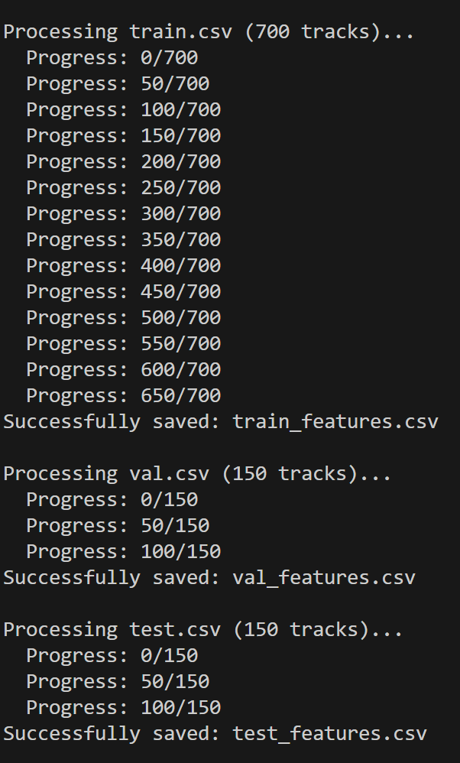
Created 3 files train_features.csv, val_features.csv, test_features.csv
Ran ( python3 src/visualize_features.py ) to created a plot

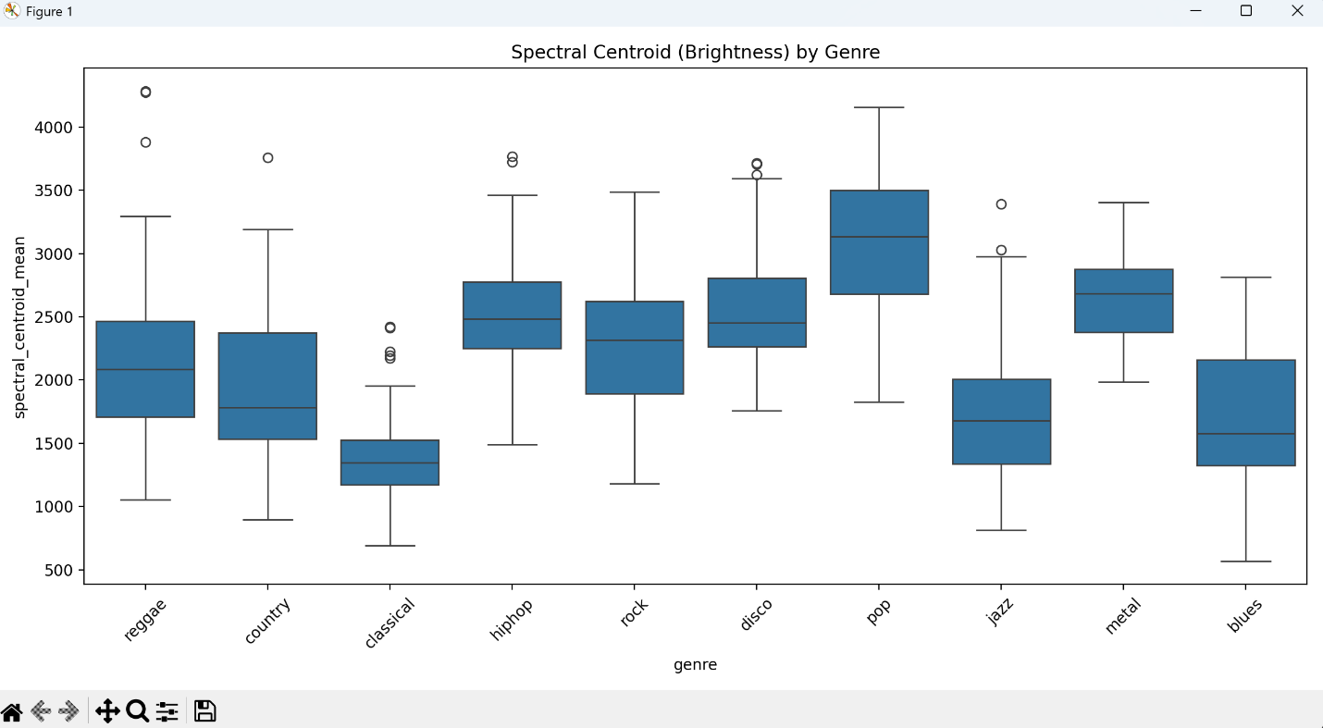
The script creates a Box Plot comparing the "Brightness" (Spectral Centroid) across all 10 genres.
Main takeaway: Genres like Metal or Pop have a much higher "Center of Mass" (Spectral Centroid) than Classical or Blues.

Milestone 3
Ater running milestone_3_ml.py
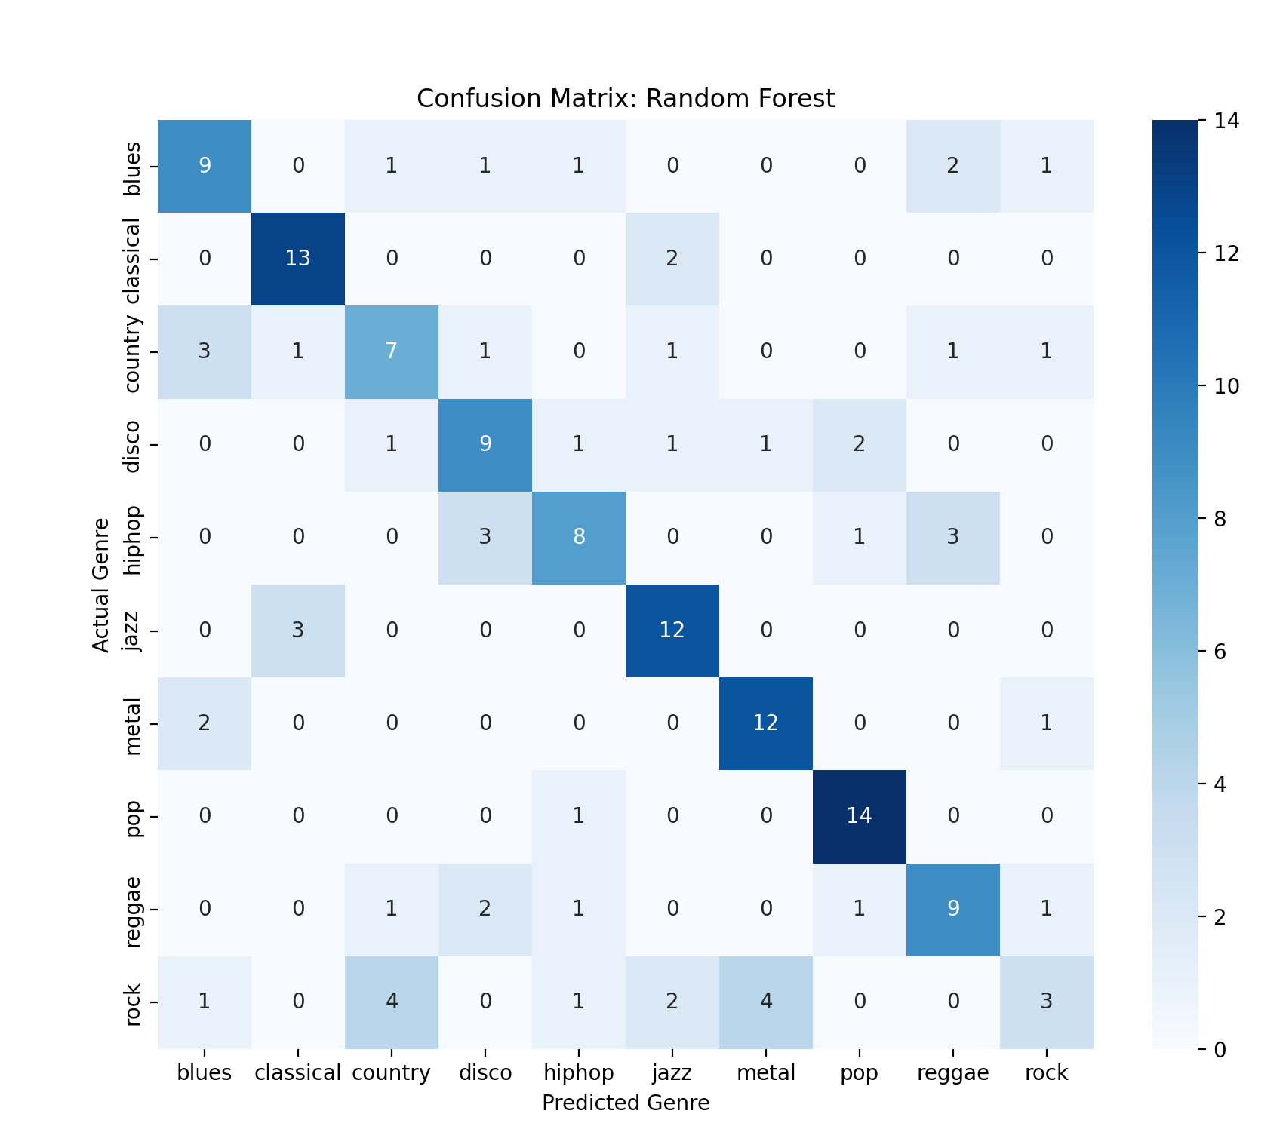

What do the results mean for your AI-Music Detector goal?
Now that you have the data, here is why this specific set of features is so powerful for detecting AI music:
What Milestone 2 means for milestone 5(AI)
- The MFCC "Signature": Human-made instruments have natural physical resonances. AI-generated music often has "spectral holes"—frequencies that are mathematically too perfect or unnaturally quiet. By having 20 MFCCs, you can spot these anomalies.
- Spectral Rolloff: This measures the frequency below which 85% of the energy lies. AI music sometimes struggles with high-frequency "hiss" or artifacts. If your "Synthetic" genre (when you add it later) has a much higher Rolloff than "Classical," that's your smoking gun.

